CSE 422: Computer Graphics Lab

Lab 05: Implementation of Midpoint Circle Drawing Algorithm Using OpenGL

Lab Objective
After completing this lab, students will be able to:
- Understand the Midpoint Circle Drawing Algorithm.
- Calculate circle pixels using integer arithmetic.
- Utilize the eight-way symmetry property of a circle.
- Implement the Midpoint Circle Drawing Algorithm using OpenGL.
- Visualize the effect of changing the circle radius and center.

Background
Unlike a mathematical circle, a computer screen consists of discrete pixels.
Therefore, a computer cannot draw a perfect continuous circle. Instead, it selects the pixels that best approximate the circular boundary.
The Midpoint Circle Drawing Algorithm is one of the most efficient circle rasterization techniques because:
- It uses only integer arithmetic.
- It avoids trigonometric calculations.
- It exploits the symmetry of a circle.
- It produces smooth circular boundaries.

Mathematical Idea
A circle centered at (xc, yc) with radius r satisfies (x−xc)² +(y−yc)² =r²
Instead of testing every pixel, the algorithm evaluates the midpoint between two candidate pixels.
At each iteration, only two possible pixels are considered:
East: (x+1, y)

South-East: (x+1, y−1)
The decision parameter determines which pixel is closer to the actual circle.

Why Do We Calculate Only One Octant?
A circle is symmetric about the x-axis, y-axis, and the line y=x
Therefore, if one point (x,y) is known, seven additional points can be generated immediately.
The eight symmetric points are
(xc+x, yc+y)

(xc+y, yc+x)

(xc+y, yc−x)

(xc+x, yc−y)

(xc−x, yc−y)

(xc−y, yc−x)

(xc−y, yc+x)

(xc−x, yc+y)
Therefore, the algorithm computes only the first octant and obtains the remaining seven points through symmetry.
This significantly reduces computation time.

Initial Conditions
For a circle of radius r
Initialize x = 0, y = r
Initial decision parameter, p₀ = 1 – r
Updating the Decision Parameter

Case 1
If
p < 0
choose
(x+1, y)
Update
x = x + 1

p = p + 2x + 1

Case 2
If
p ≥ 0
choose
(x+1, y−1)
Update
x = x + 1
y = y − 1
p = p + 2x + 1 − 2y
Continue until
x > y

Midpoint Circle Algorithm (Pseudocode)
Input radius r
x = 0
y = r
p = 1 - r
while x <= y
Plot 8 symmetric points
if p < 0
x = x + 1
p = p + 2x + 1
else
x = x + 1
y = y - 1
p = p + 2x + 1 - 2y

end while

OpenGL Program Structure
Students should complete the algorithm inside the TODO section.
#include <GL/gl.h>
#include <GL/glut.h>
#include <stdio.h>

int radius;

void init()
{
glClearColor(0,0,0,0);

glMatrixMode(GL_PROJECTION);
glLoadIdentity();

glOrtho(-100,100,-100,100,-1,1);
}

void display()
{
glClear(GL_COLOR_BUFFER_BIT);

glColor3f(1,1,1);

glBegin(GL_POINTS);

/*****************************************

TODO
x = 0
y = radius
p = 1 - radius
while x <= y
Plot 8 symmetric points (USE GLVERTEX2F)
if p < 0
x = x + 1
p = p + 2x + 1
else
x = x + 1
y = y - 1
p = p + 2x + 1 - 2y

end while
******************************************/
glEnd();
glFlush();
}
int main(int argc,char** argv)
{
printf("Enter Radius : ");
scanf("%d",&radius);

glutInit(&argc,argv);

glutInitDisplayMode(GLUT_SINGLE|GLUT_RGB);

glutInitWindowSize(600,600);

glutCreateWindow("Midpoint Circle");

init();

glutDisplayFunc(display);

glutMainLoop();

return 0;
}

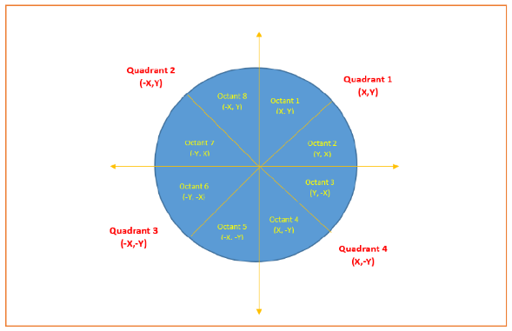Student Tasks

Task 1
Complete the Midpoint Circle Drawing Algorithm.

Task 2
Draw a circle of radius 20 centered at (0,0)

Task 3
Modify the program so that the circle is centered at (30,20) instead of the origin.
(Hint: Add the center coordinates to every plotted point.)

Task 4
Change the radius to 40. Observe how the plotted pixels change.

Task 5 (Advanced)
Modify the program to allow the user to input:
- Center coordinates (xc,yc)
- Radius r and generate the corresponding circle.

Discussion Questions
- Why does the Midpoint Circle Algorithm compute only one octant?
- What is the purpose of the decision parameter?
- Why does the algorithm stop when x>y?
- Why is the Midpoint Circle Algorithm more efficient than using the circle equation directly?
- How are the remaining seven points obtained from a single calculated point?
- How would you modify the program to draw circles at arbitrary centers?

